**Insert School Logo**

**Semester One**

**Examination 2020**

**Question/Answer booklet**

**MATHEMATICS**

**METHODS UNIT 1**

**Section One:**

**Calculator–free**

|  |
| --- |
| Student Name: _____________________________________ |
| Teacher’s Name: _____________________________________ |
|  |

**Time allowed for this section**

Reading time before commencing work: five minutes

Working time for paper: fifty minutes

**Material required/recommended for this section**

**To be provided by the supervisor**

This Question/Answer booklet

Formula Sheet

**To be provided by the candidate**

Standard items: pens (blue/black preferred), pencils (including coloured), sharpener, correction tape/fluid, erasers, ruler, highlighters

Special Items: nil

**Important note to candidates**

No other items may be taken into the examination room. It is **your** responsibility to ensure that you do not have any unauthorised notes or other items of a non–personal nature in the examination room. If you have any unauthorised material with you, hand it to the supervisor **before** reading any further.

**Structure of this paper**

|  |  |  |  |  |  |
| --- | --- | --- | --- | --- | --- |
|  | Number of questions available | Number of questions to be attempted | Working time (minutes) | Marks available | Percentage of exam |
| **Section One**  **Calculator—free** | **8** | **8** | **50** | **52** | **35** |
| Section Two  Calculator—assumed | 17 | 17 | 100 | 98 | 65 |
|  | | | | 150 | 100 |

**Instructions to candidates**

1. The rules for the conduct of Western Australian external examinations are detailed in the

*Year 12 Information Handbook 2020.* Sitting this examination implies that you agree to abide by these rules.

1. Answer the questions according to the following instructions.

**Show all your working clearly.** Your working should be in sufficient detail to allow your

answers to be checked readily and for marks to be awarded for reasoning. Incorrect answers given without supporting reasoning cannot be allocated any marks. For any question or part question worth more than two marks, valid working or justification is required to receive full marks. If you repeat an answer to any question, ensure that you cancel the answer you do not wish to have marked.

It is recommended that you **do not use pencil**, except in diagrams.

1. You must be careful to confine your responses to the specific questions asked and to follow any instructions that are specific to a particular question.
2. Spare pages are included at the end of this booklet. They can be used for planning your responses and/or as additional space if required to continue an answer.

* Planning: If you use the spare pages for planning, indicate this clearly at the top of the page.
* Continuing an answer: If you need to use the space to continue an answer, indicate in the original answer space where the answer is continued, i.e. give the page number. Fill in the number of the question that you are continuing to answer at the top of the page.

1. The Formula Sheet is **not** handed in with your Question/Answer Booklet.

# Section One: Calculator–free 35% (52 marks)

This section has **eight (8)** questions. Attempt **all** questions. Write your answers in the spaces provided.

Spare pages are included at the end of this booklet. They can be used for planning your responses and/or as additional space if required to continue an answer.

* Planning: If you use the spare pages for planning, indicate this clearly at the top of the page.
* Continuing an answer: If you need to use the space to continue an answer, indicate in the original answer space where the answer is continued, i.e. give the page number. Fill in the number of the question(s) that you are continuing to answer at the top of the page.

Working time: 50 minutes

**Question 1 (4 marks)**

(a) If sin 20°  = *p,* determine sin 340°  in terms of *p.* (1 mark)

(b) Given that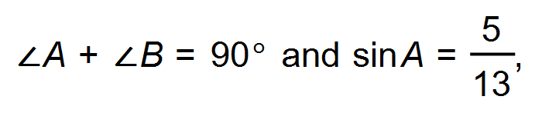evaluate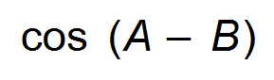. (3 marks)

**Question 2 (11 marks)**

In the diagram P, Q and R are the points (6, 0), (9, 0) and (12, 6) respectively.

Line PS is parallel to QR. Line ST is parallel to the x-axis.

The equation of line OR is given by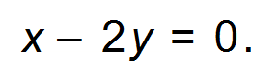

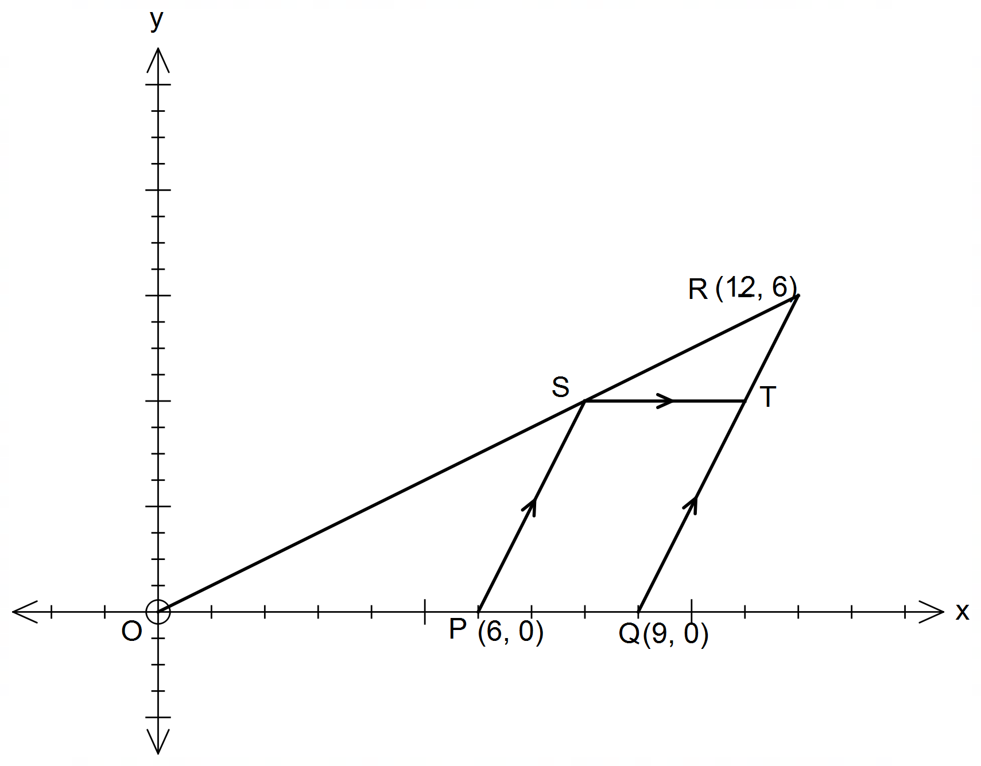

(a) Show that the equation of PS is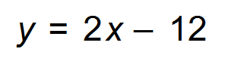. (3 marks)

(b) Find the coordinates of point S. (2 marks)

(Question 2 continued)

(c) Find the coordinates of point T. (3 marks)

(d) State the simplified ratio of PS : TR (3 marks)

**Question 3 (4 marks)**

Daniel decides to plant trees as part of his #climateaction project. He has three jarrah trees and two paperbark trees. On each of the next three days, Monday, Tuesday and Wednesday, Daniel selects one tree at random to plant.

Find the probability that Daniel

(a) selects a jarrah tree to plant on Monday. (1 mark)

(b) plants the same kind of tree on all three days. (1 mark)

(c) does not plant the same kind of tree on consecutive days.

(1 mark)

(d) plants a Jarrah tree on Tuesday, given that he planted a Paperbark on Monday. (1 mark)

**Question 4 (4 marks)**

Consider the graph with the equation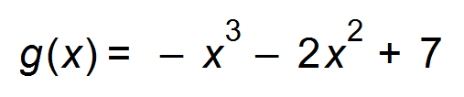.

(a) State the degree of the polynomial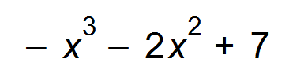. (1 mark)

(b) Describe the behaviour of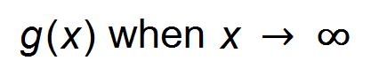. (1 mark)

(c) The graph of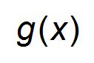 is translated 3 units to the right and then dilated vertically by factor 2.

What is the *y* – intercept of the resulting graph? (2 marks)

**Question 5 (3 marks)**

Given that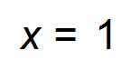is a solution to the equation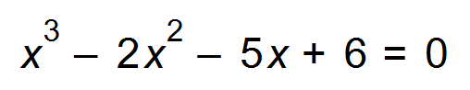, find the remaining solutions. (3 marks)

**Question 6 (14 marks)**

(a) Determine the amplitude and period of the function given by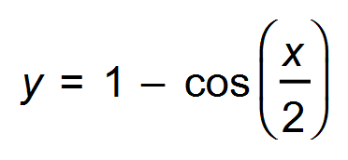. (2 marks)

(b) Sketch the graph of on the axes below where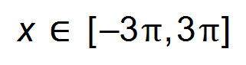. (3 marks)

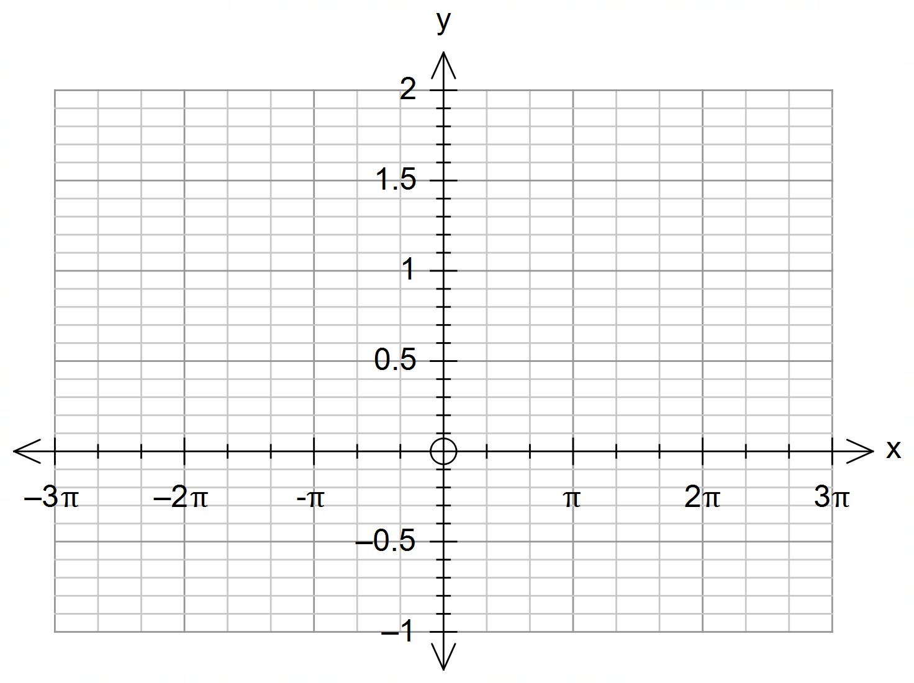

(c) The graph ofundergoes the following transformations:

A vertical translation of 1 unit down and then a horizontal translation of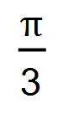units to the right.

(i) State the equation of the transformed graph. (2 marks)

(ii) Sketch this graph on the same set of axes above. (3 marks)

(Question 6 continued)

(d) Using the graphs, or otherwise, solve the following equations.

(i) 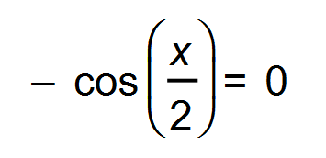where. (2 marks)

(ii) 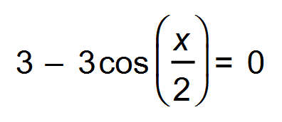 where. (1 mark)

(e) State the function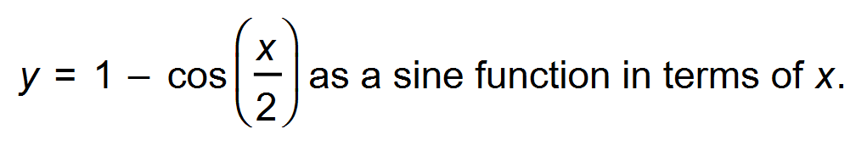 (1 mark)

**Question 7 (9 marks)**

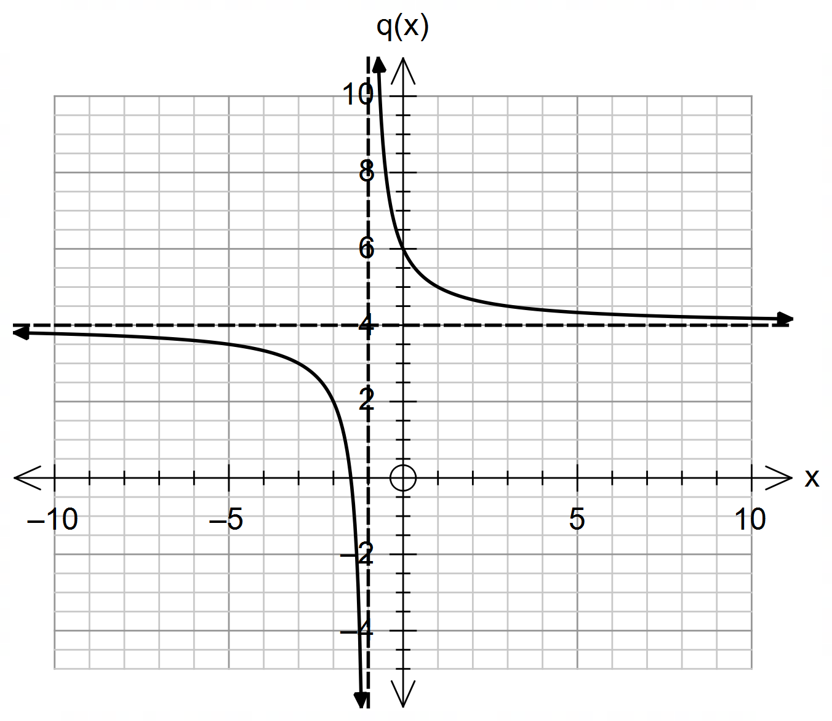The graphs of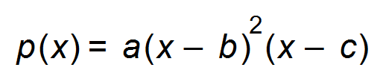 and 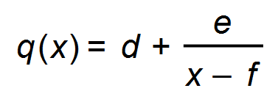 are shown below:

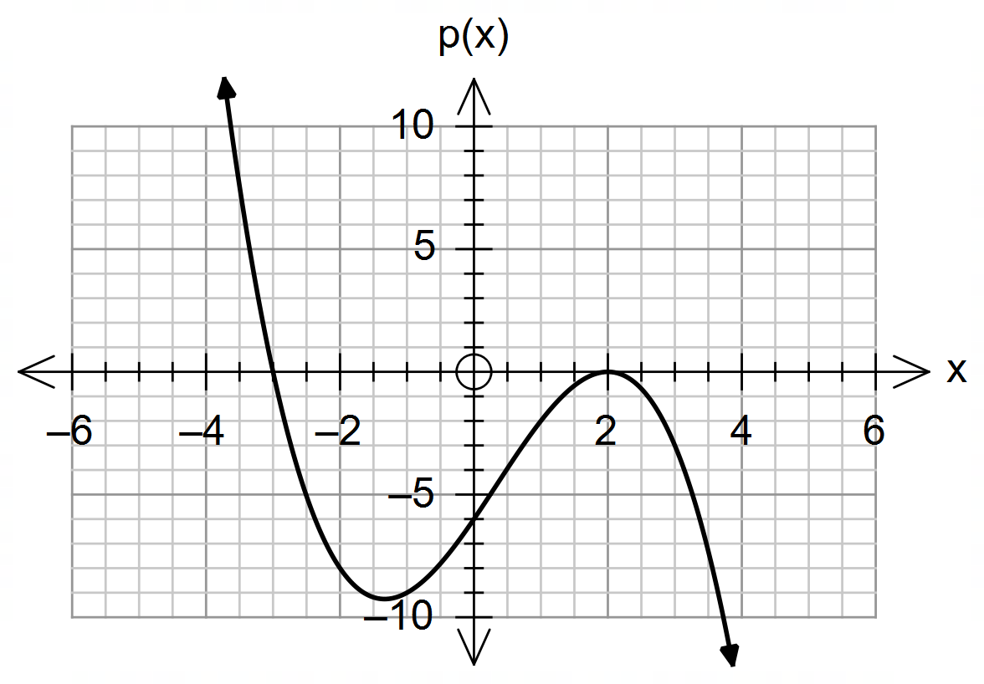

(a) Find the values of *a, b, c,* *d*, *e* and *f*. (6 marks)

(b) State the equation of the vertical asymptote of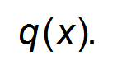 (1 mark)

(c) State the domain of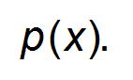 (1 mark)

(d) State the range of (1 mark)

**Question 8 (3 marks)**

The following information is given:

* 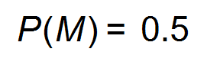
* 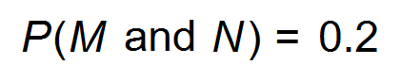
* 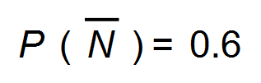

Draw a Venn diagram to represent this information and determine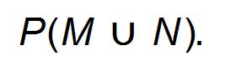 (3 marks)

End of Questions

**Additional working space**

Question number(s): ……………………